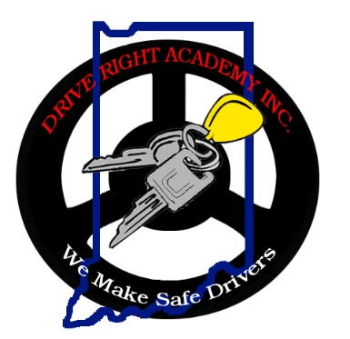
Fees
Student Information

Name (Full/Legal) First: ___________________ MI: _____ Last: __________________________

Address: __________________________________________________________

City: ___________________________ ZIP: _______________

Date of Birth: ____________________ Age: __________

High/Middle School attending: ___________________________

Phone Contacts: Home: ___________________ Parent Cell: ___________________ Student Cell: ___________________

Preferred Email (reqd. for Online): ______________________________________________________ (please print clearly)
The online program is $410.00. You have the option to add the Drive Test upon the conclusion of the behind-the-wheel portion for an additional fee of $50.00. Additional drive time may be scheduled for $75.00 per hour.

Provided the student has completed a different online course and only requires the behind-the-wheel instruction (BTW) the fee is $380.00. A copy of the Certificate of Completion from the online course must accompany this registration form.

The following additional fees may be assessed:
- $30.00 for missed drives without a 24-hour notice
- $25.00 for a returned check

Obtaining a permit
Once a student has passed the online session, they will receive a CDE form to obtain their learner’s permit from the BMV. In some circumstances, CDE forms may be provided prior to conclusion of classroom session.
*Reminder: Student will be required to pass written exam at BMV to obtain permit.

Parental Consent
I hereby give consent for my son/daughter to be enrolled in the Drive Right Academy Inc. driver education course. The course includes thirty hours of classroom instruction followed by six (6) hours of behind-the-wheel instruction. The driver education learner’s permit is not valid if my child does not complete the driver education class or meet all course requirements. When the driver education learner’s permit expires, all privileges expire with it. I understand that I am responsible for the safekeeping of permits issued by the school and the BMV and that an additional fee may be incurred for a lost permit, whether it be the plastic or paper copy.

I understand that Drive Right Academy Inc. will not refund any fee, tuition, deposit, or any portion should the school be ready, willing, and able to fulfill its part of the contract. An owner, officer, instructor, agent, or employee of this school shall not state nor give the impression to a student that upon completion of the course, they will guarantee the securing of a driver’s license to operate a motor vehicle.

Parent’s signature: ___________________________________ Date: ______________________________

Complete this registration form with check made payable to: Drive Right Academy Inc. and mail to:
Course Fee: Online & BTW: $410.00
Drive Only: $380.00

Drive Right Academy Inc.
PO Box 670
Auburn, IN 46706

